Experiment No – 9
Title / Aim :- Implement localStorage and sessionStorage to save user preferences like theme settings.
Software/Tools Required :-
- Visual Studio Code (VS Code)
- Google Chrome / Any Web Browser
- HTML
- JavaScript

CODE:-
Index.html
<!DOCTYPE html>
<html lang="en">
<head>
<meta charset="UTF-8">
<meta name="viewport" content="width=device-width, initial-scale=1.0">

<title>MyStyle Preference Manager</title>

<link rel="stylesheet" href="style.css">
</head>
<body>
<div class="box">
<h1>⚙️ MyStyle</h1>
<p class="subtitle">Preference Manager</p>
<hr>
<h3>Choose Theme</h3>
<div class="themes">
<label>
<input type="radio" name="theme" value="light" checked>
☀️ Light
</label>
<label>
<input type="radio" name="theme" value="dark">
🌙 Dark
</label>
</div>
<button id="clearBtn">
CLEAR PREFERENCE
</button>
<button id="localBtn">
SAVE USING LOCAL STORAGE
</button>
<button id="sessionBtn">
SAVE USING SESSION STORAGE
</button>
<p id="status">Status: No preference saved</p>
</div>
<script src="script.js"></script>
</body>
</html>

Script.js
const themes = document.querySelectorAll(
'input[name="theme"]'
);

const clearBtn = document.getElementById("clearBtn");
const localBtn = document.getElementById("localBtn");
const sessionBtn = document.getElementById("sessionBtn");
const status = document.getElementById("status");
// APPLY THEME
function applyTheme(theme) {
document.body.classList.toggle(
"dark",
theme === "dark"
);
}
// GET SELECTED THEME
function getTheme() {
return document.querySelector(
'input[name="theme"]:checked'
).value;
}
// SAVE USING LOCAL STORAGE
localBtn.addEventListener("click", function() {
const theme = getTheme();
localStorage.setItem("theme", theme);
applyTheme(theme);
status.textContent =
"Status: Preference saved using Local Storage ✓";
});
// SAVE USING SESSION STORAGE
sessionBtn.addEventListener("click", function() {
const theme = getTheme();
sessionStorage.setItem("theme", theme);
applyTheme(theme);
status.textContent =
"Status: Preference saved using Session Storage ✓";
});
// CLEAR PREFERENCE
clearBtn.addEventListener("click", function() {
localStorage.removeItem("theme");
sessionStorage.removeItem("theme");
document.querySelector(
'input[value="light"]'
).checked = true;
applyTheme("light");
status.textContent =
"Status: Preferences cleared ✓";
});
// CHANGE THEME PREVIEW
themes.forEach(function(theme) {
theme.addEventListener("change", function() {
applyTheme(getTheme());
});
});
// LOAD SAVED PREFERENCE
const savedTheme =
localStorage.getItem("theme") ||
sessionStorage.getItem("theme");
if (savedTheme) {
document.querySelector(
`input[value="${savedTheme}"]`
).checked = true;
applyTheme(savedTheme);
status.textContent =
"Status: Saved preference loaded ✓";
}

Style.css
* {
box-sizing: border-box;
}
body {
margin: 0;
font-family: Arial, sans-serif;
background: #E0E7FF;
color: #1E293B;
display: flex;
justify-content: center;
align-items: center;
min-height: 100vh;
transition: 0.3s;
}
/* MAIN BOX */
.box {
width: 380px;
background: white;
padding: 30px;
border-radius: 15px;
text-align: center;
box-shadow: 0 8px 25px rgba(0, 0, 0, 0.15);
}
/* HEADING */
h1 {
margin-bottom: 5px;
color: #4F46E5;
}
.subtitle {
color: #64748B;
margin-top: 0;
}
hr {
border: none;
border-top: 1px solid #E2E8F0;
margin: 20px 0;
}
/* THEMES */
.themes {
display: flex;
justify-content: center;
gap: 35px;
margin: 20px 0 25px;
}
.themes label {
cursor: pointer;
}
/* BUTTONS */
button {
width: 100%;
padding: 12px;
margin-top: 10px;
border: none;
border-radius: 7px;
background: #4F46E5;
color: white;
font-weight: bold;
cursor: pointer;
}
button:hover {
background: #3730A3;
}
/* CLEAR BUTTON */
#clearBtn {
background: #64748B;
}
#clearBtn:hover {
background: #475569;
}
/* STATUS */
#status {
margin-top: 20px;
font-size: 14px;
font-weight: bold;
color: #16A34A;
}
/* DARK THEME */
body.dark {
background: #0F172A;
color: white;
}
body.dark .box {
background: #1E293B;
}
body.dark .subtitle {
color: #CBD5E1;
}
body.dark hr {
border-color: #475569;
}
body.dark h1 {
color: #A78BFA;
}

Output
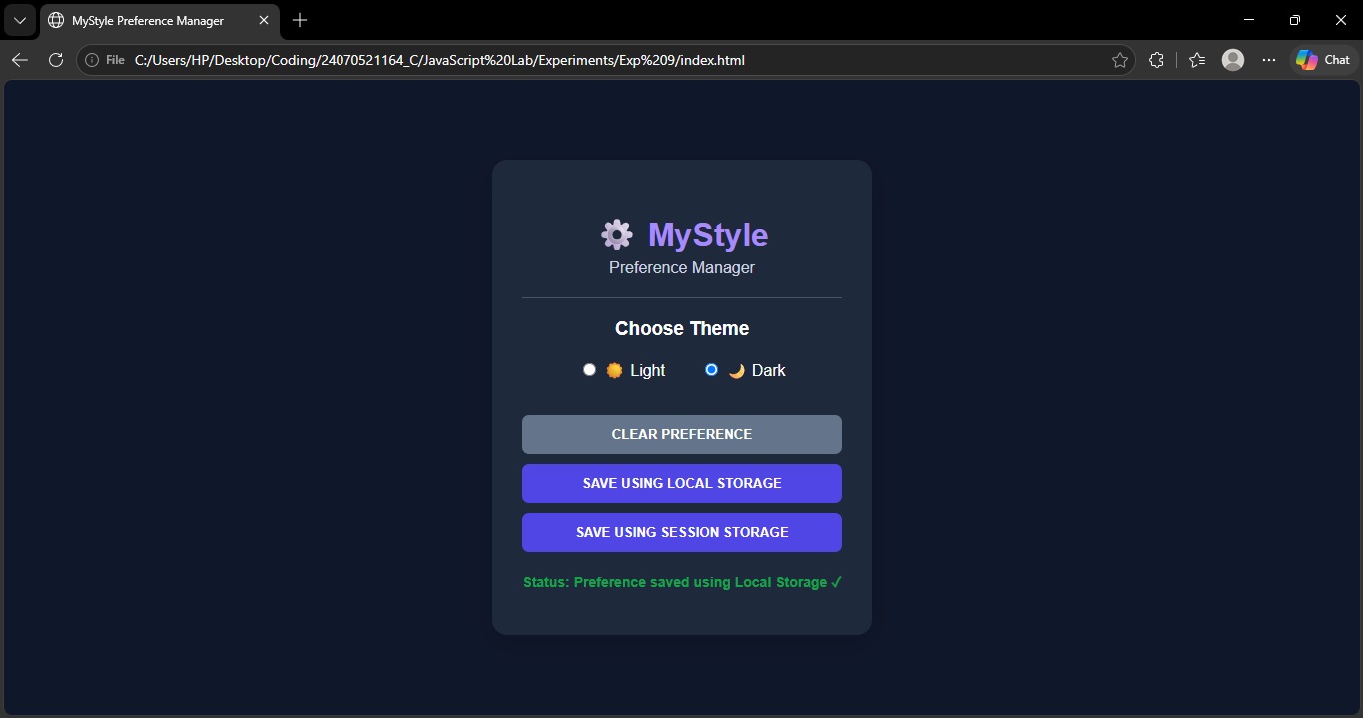

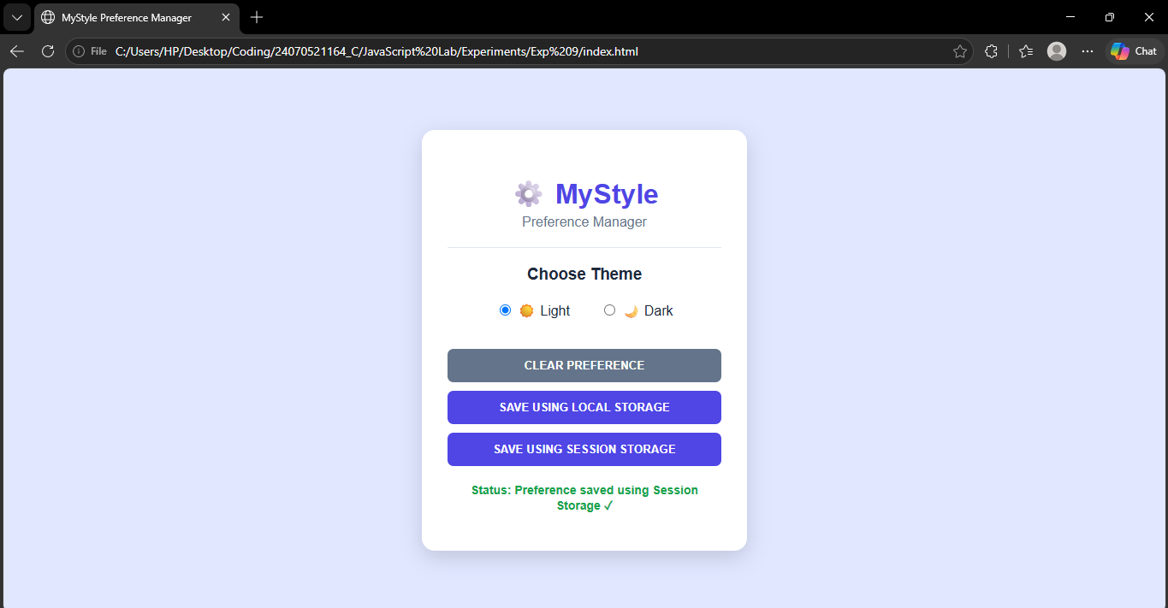

Result / Conclusion :-
The MyStyle Preference Manager was successfully developed using HTML, CSS, and JavaScript. The application allows users to select a Light or Dark theme and save the preference using either localStorage or sessionStorage. The saved preference is automatically retrieved and applied when the page is loaded. The Clear Preference button removes the stored data and resets the theme. Thus, the experiment provided practical understanding of Web Storage, event handling, DOM manipulation, and user preference management in JavaScript.

